**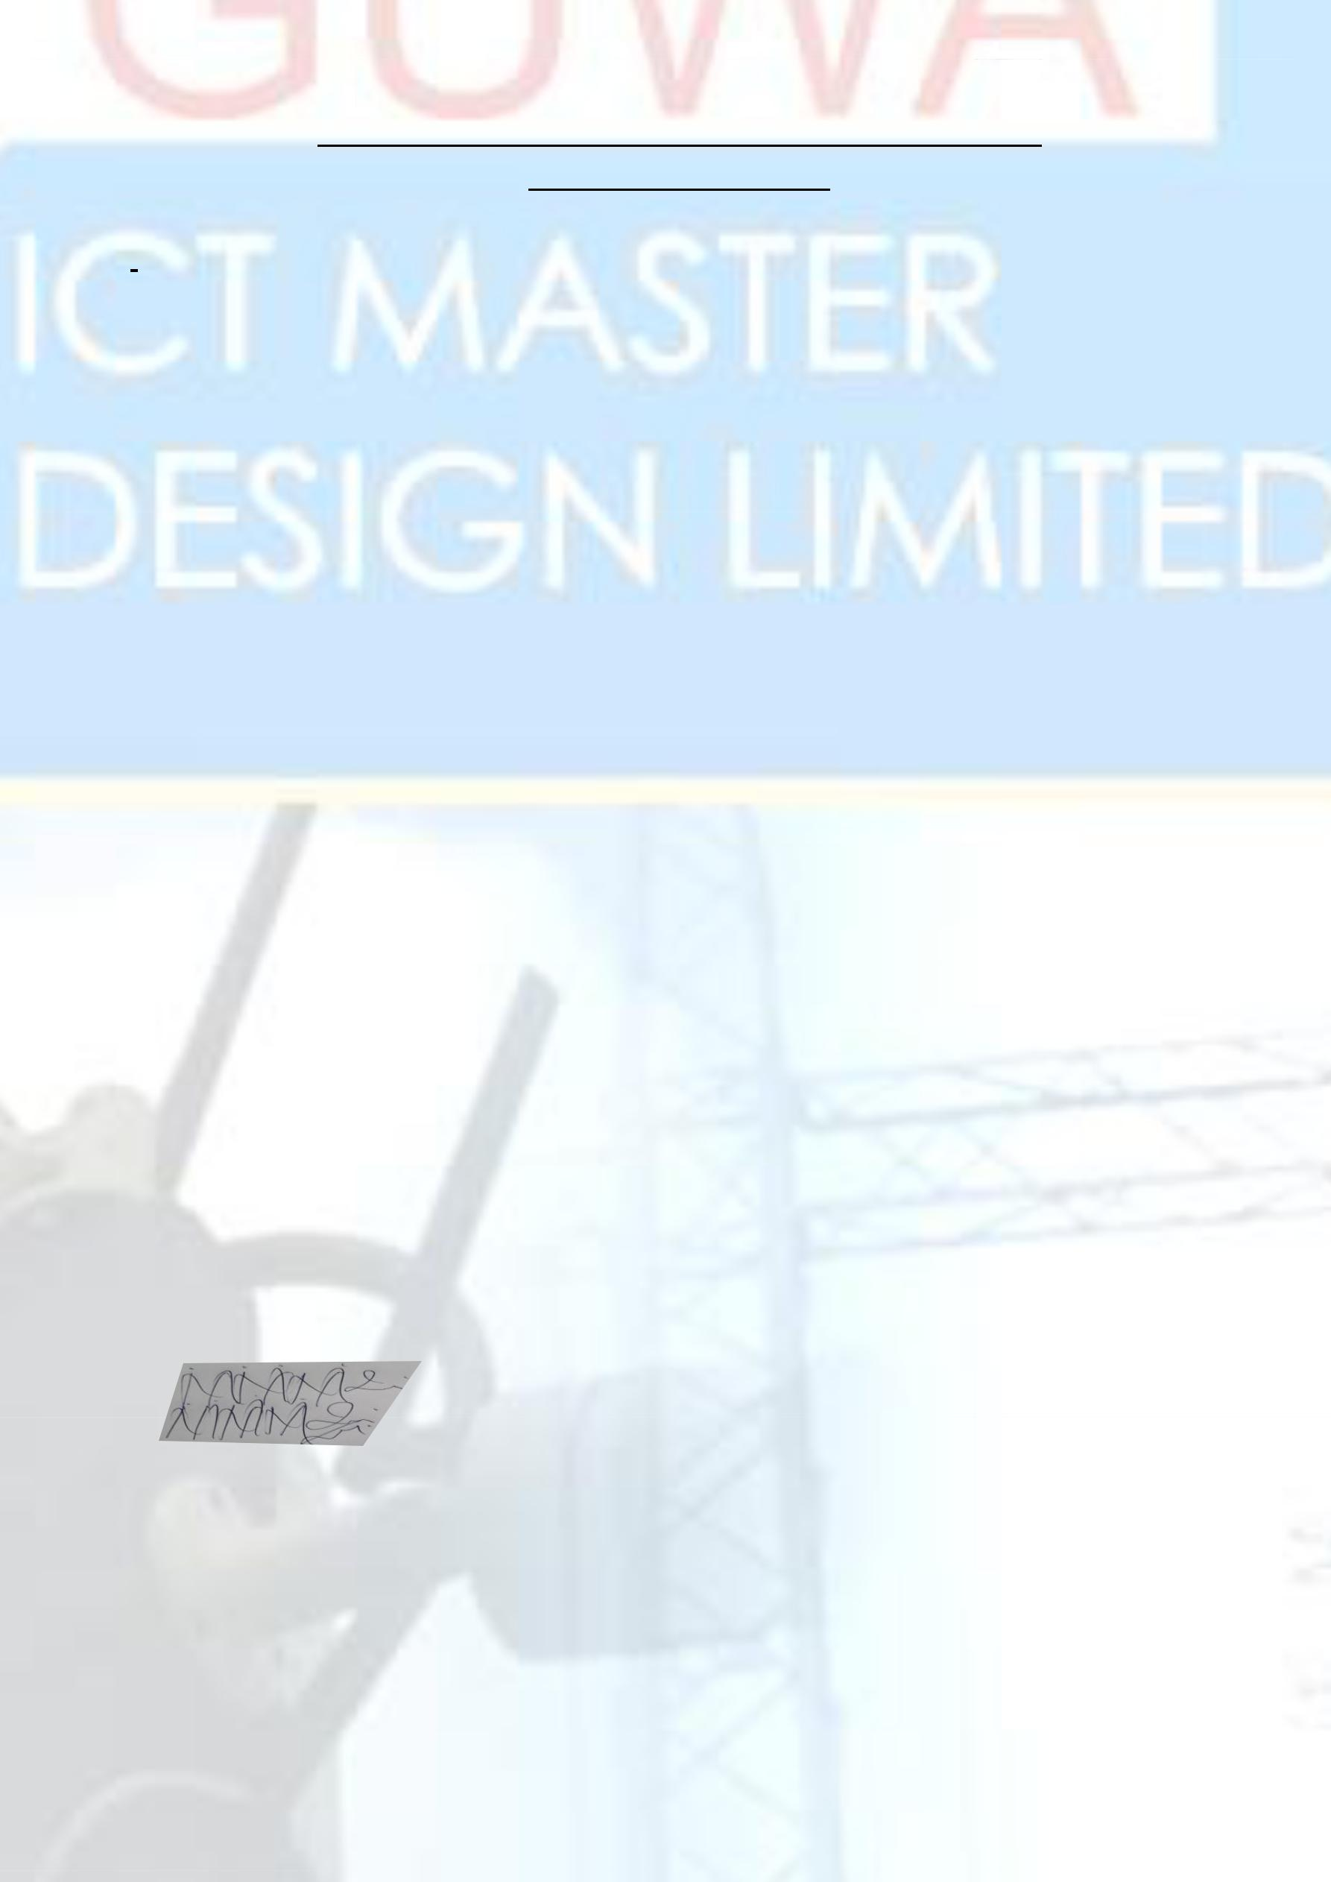****OGUWA CEO ADDRESS**

We hereby introduce to you our company OGUWA ICT MASTER DESIGN LIMITED, an Information Technology firm also specialty in Centralized CCTV Installation/Maintenance, Safety Gadgets Installation, Internet Service provider Indoor/Outdoor Wi-Fi, Installation of Satellite and design development, Water hosiery Installation, Telecommunication Installation, Computer Engineering and remote view host management. OGUWA ICT MASTER is duly incorporated in Nigeria with her head office in Lagos.

We have the capacity to handling multi-complex projects such as CCTV Monitoring System installation, Safety gadgets and Remote access Satellite Installation and general Advance new model interactive devices around the world, given our position and focused on technical and centralize projects remote management team.

May we state that we strive as an independent project management policy which guarantees an on –the-spot decision making (quick decision ) on project needs, therefore reducing delay tendencies on projects real time. This implies that we lay emphasis on the need to deliver clients projects a high quality and on time.

We also us the opportunity to empower the church youths in term of training for the duration of one year on deferent area of Information Technology such as;

* Installation of Centralized IP cameras (CCTV) and how to view it in any other country you are through your mobile App with good Notification Safety Detection
* Installation of IP phones and internal Telecommunication system hybrid
* Interlink of all Satellites and signal transmissions Outdoor and Indoor hybrid
* Safety Gadgets and water sensor Detection
* Internet Service provider Outdoor and Indoor Hotspot

However, we would be very delighted if we could be considered for a brief meeting in your organization and any kind, to sell our products in stock to you that we considered experience of Information management on CCTV installation and any others I.T jobs etc.

Yours faithfully,

For: Oguwa ICT Master Design Limited

**Engr. Samuel Sule**

**MD/CEO**